
Argo Use Case Examples
By
EBOWOICHO EMMANUEL ONAH
500252011

Example 1.
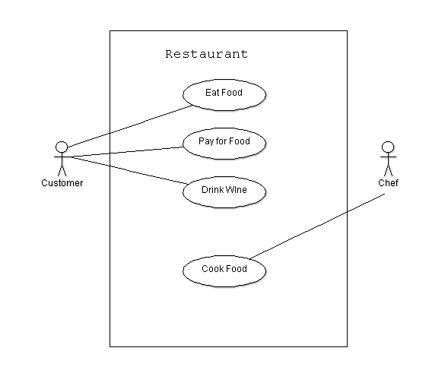
This is a Restaurant Scenario.

In this restaurant scenario we have 2 Actors: Consumer and Chef. And in this scenario we also have 4 use cases displayed in an ellipse shape in the diagram above.

The Customer comes into the restaurant to eat and pay for his food and also have a bottle of wine to drink.

The Chef who works in the restaurant is responsible for cooking the food in the restaurant.

Example 2.
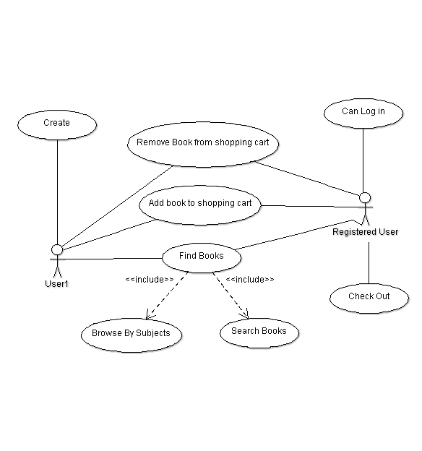
In this second example we have 2 Actors: User1 and Registered User. We also have 8 use cases all displayed above in an ellipse shape.
The User1 has different steps to follow; User1 creates his name to be registered or he can browse the set of books anonymously.
The Registered User can log in because he is registered and can check out.
User1 and the Registered User can both find books, add books to the shopping carts and they can also remove books from the shopping cart.
Finding the book involves two processes for the actors, either they find the book by browsing by the subject of the book or
they can find the book they want by searching through all books in general.

